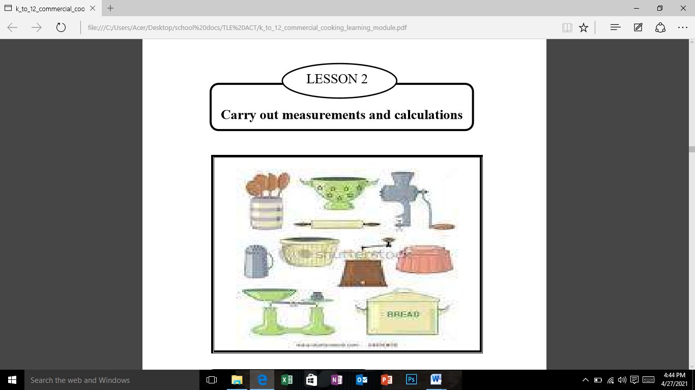

**How to Calculate Markup Percentage**

Markup is the difference between how much an item costs you, and how much you sell that item for--it's your profit per item. Any person working in business or retail will find the skill of being able to calculate markup percentage very valuable.

**Instructions**

1. Calculate your peso markup. This is done by subtracting your buying price from your selling price.

**Example**

Selling price 15.00

Purchase cost/buying price - 10.00

Peso markup 5.00

2. Decide whether you want to calculate your percentage markup based on cost or selling price. Once you choose which you will be using to calculate, it is important you stick to the method you choose throughout all your calculations, or you will end up with faulty data. If you decide to calculate your percent markup based on cost, go on to Step 3. If you decide to calculate your percent markup based on selling price, go on to Step 4.

3. Calculate percent markup based on cost. This is done by dividing the peso markup by the cost.

Example

Peso markup 5.00

Purchase cost/buying price ÷10.00

Percentage mark up .5 or 50%

4. Calculate your percent markup based on selling price. This is done by dividing the peso markup by the selling price.

Example

Peso markup 5.00

Selling price ÷15.00

Percentage mark up .33 or 33%

5. Make sure you consistently use either cost of the product or selling price to find the percent markup on an item. Even though the cost, selling price, and peso markup will always be the same, the percentage markup will be drastically different depending on if you calculate it using selling price or cost. Using selling price will give you a lower percentage markup (assuming you are making a profit), while using cost will give you a higher percentage markup.

